Module 2 – Artificial Neural Networks (ANN): Theory

Lesson Introduction
Mini Agenda:
- Neuron Model: Weights, Bias, Activation Functions
- Forward Propagation
- Loss Functions: MSE, Cross-Entropy
- Backpropagation & Gradient Descent

Real-World Hook
- Imagine you are Netflix trying to recommend movies. You have millions of users, thousands of movies, and tons of data.
- How can a system learn from past preferences to predict what each user might like next?
- Traditional if-else logic fails because there are too many variables — this is where Artificial Neural Networks (ANNs) come in.

Introduce Topic as a Solution
- ANN is inspired by the human brain.
- Just like our brain’s neurons connect and fire to recognize a face, ANN layers process numbers to detect patterns in data.
- ANNs are used in computer vision, NLP, speech recognition, fraud detection, and generative AI.

1. Neuron Model
What:
- A neuron takes multiple inputs, applies weights, adds bias, and passes the result through an activation function to produce an output.
Why:
- Weights decide the importance of each input.
- Bias allows shifting the activation function curve to improve learning.
When:
- Always present in neural networks.
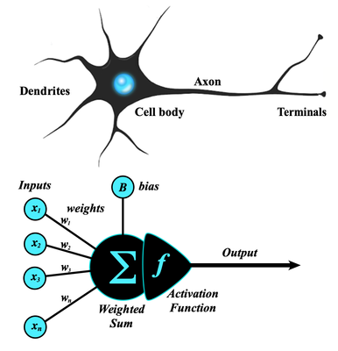
How (Mathematical Formula):
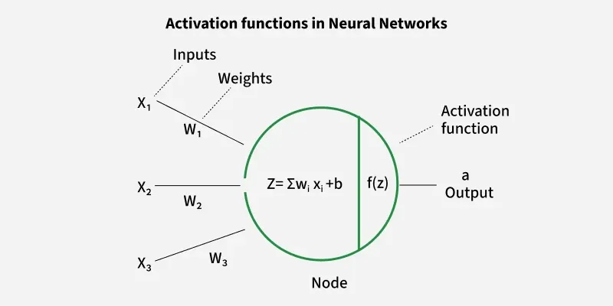
z=w1x1+w2x2+...+wnxn+bz = w_1x_1 + w_2x_2 + ... + w_nx_n + b y=f(z)y = f(z)
where ff = activation function.
Activation Functions:
- Sigmoid: Output between 0 and 1, good for probabilities.
- Tanh: Output between -1 and 1, good for centered data.
- ReLU: Fast, avoids vanishing gradient in many cases.
- Leaky ReLU: Solves ReLU’s dead neuron issue.
- Softmax: For multi-class classification.
Advantages:
- Learns non-linear relationships.
- Works for any type of input data.
Disadvantages:
- Needs large data.
- Can overfit.
Alternatives:
- Decision trees, SVM for smaller problems.

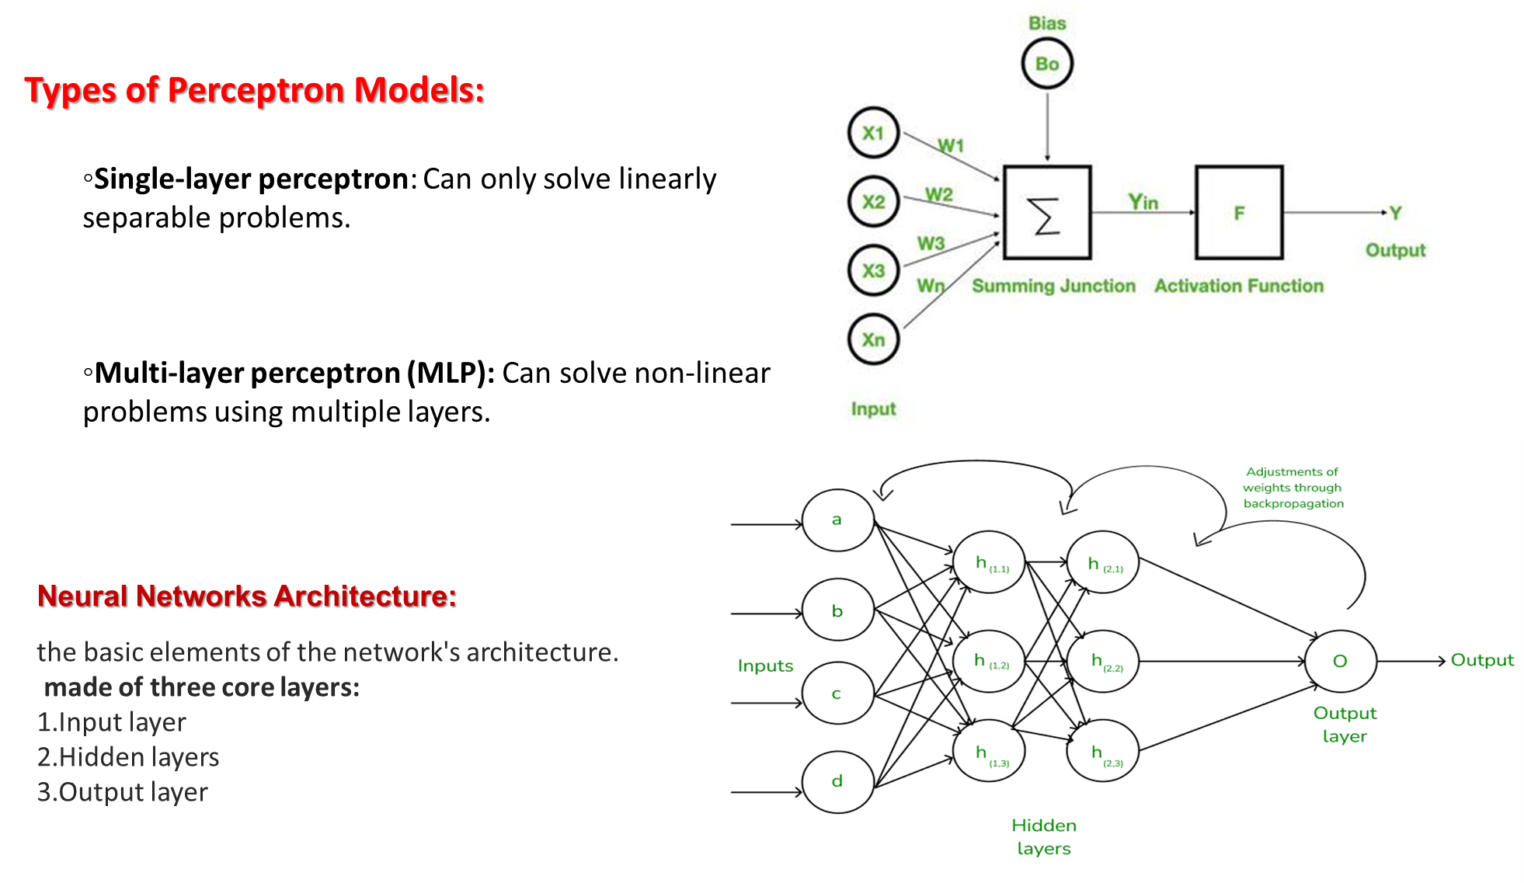

2. Forward Propagation
What:
- The process of passing input data through the network to get predictions.
Why:
- This is how ANN makes predictions before learning.
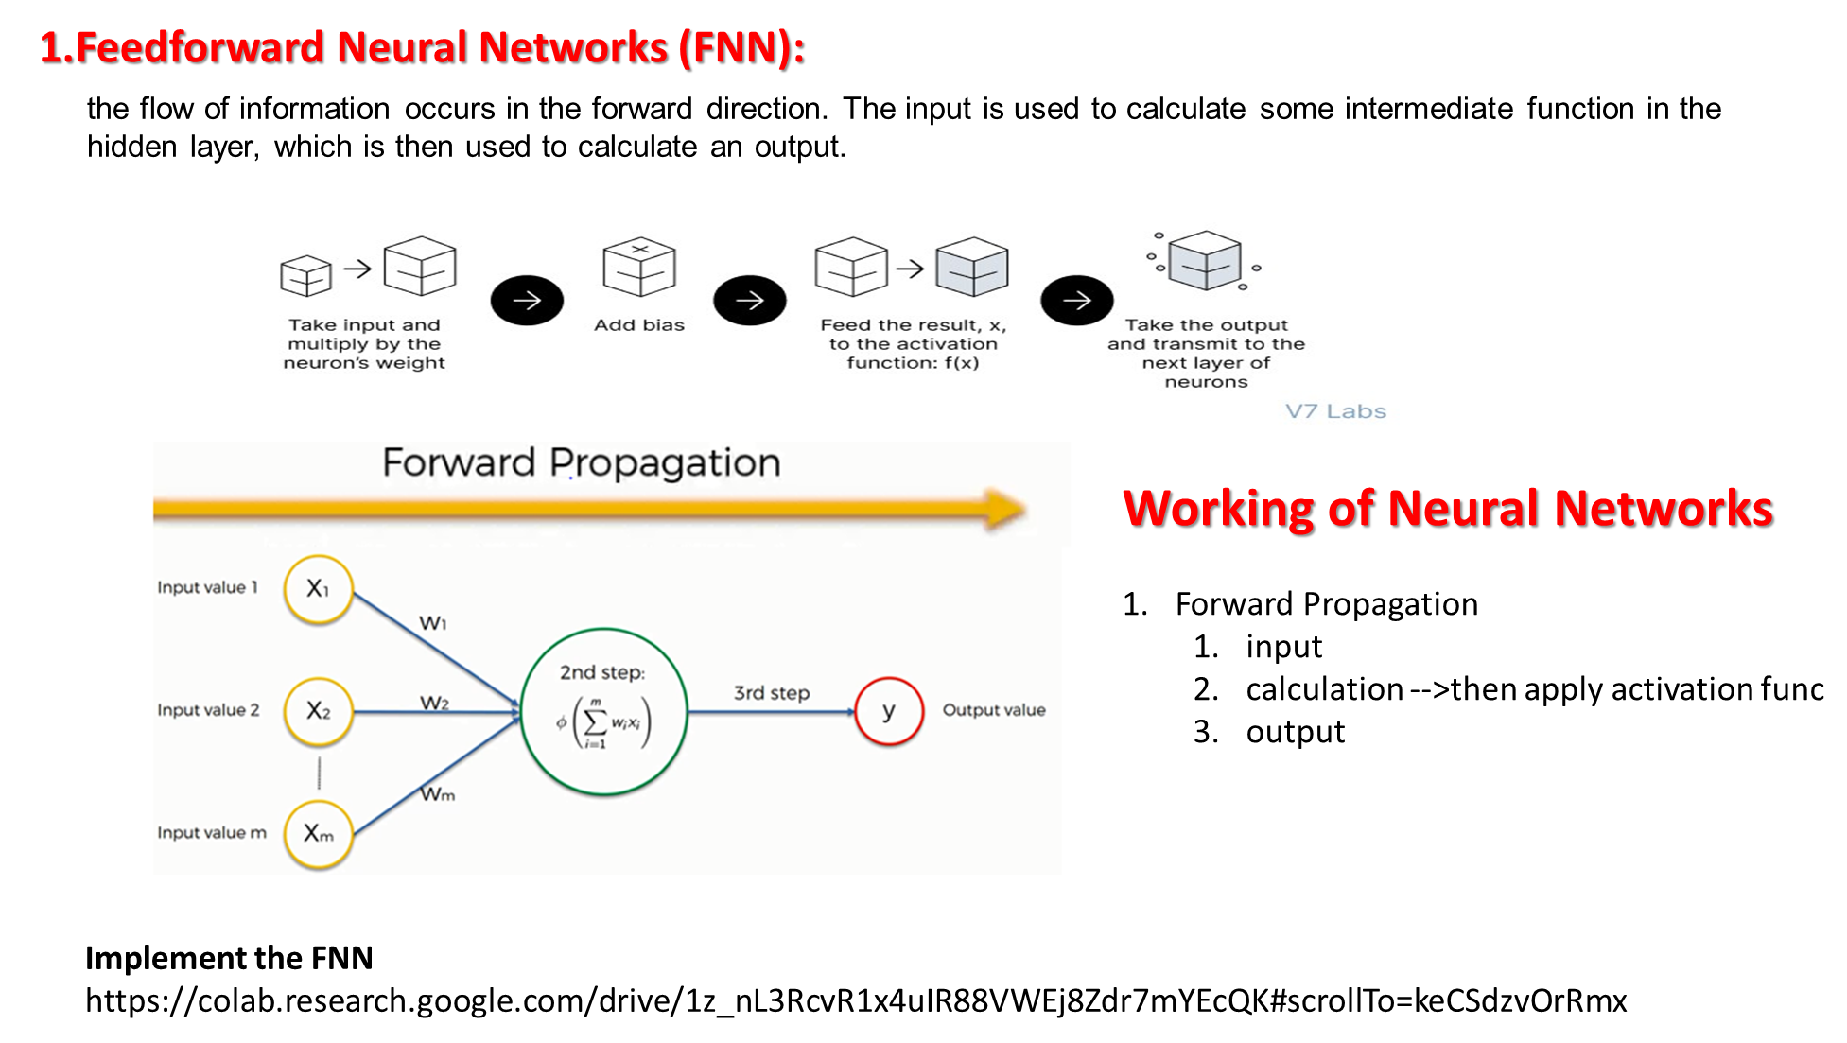
Step-by-Step Algorithm:
- Take input features.
- Multiply by weights, add bias.
- Apply activation function.
- Pass to next layer until output layer.
- Get final prediction.
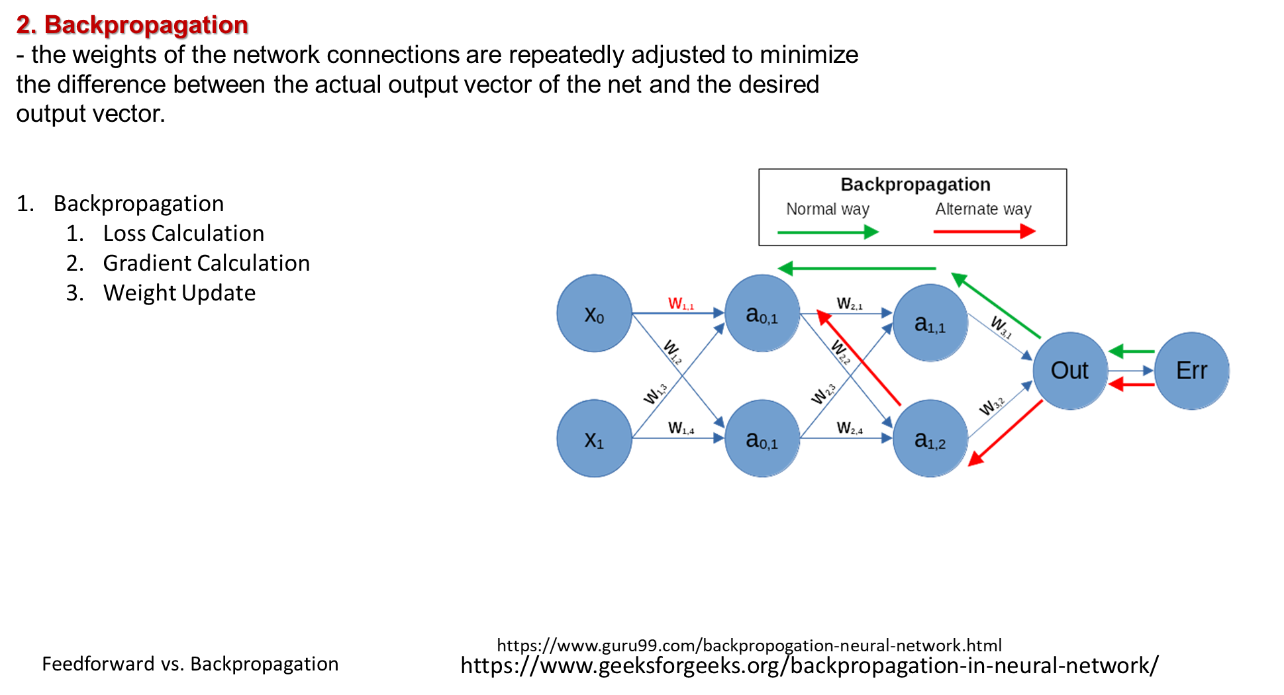

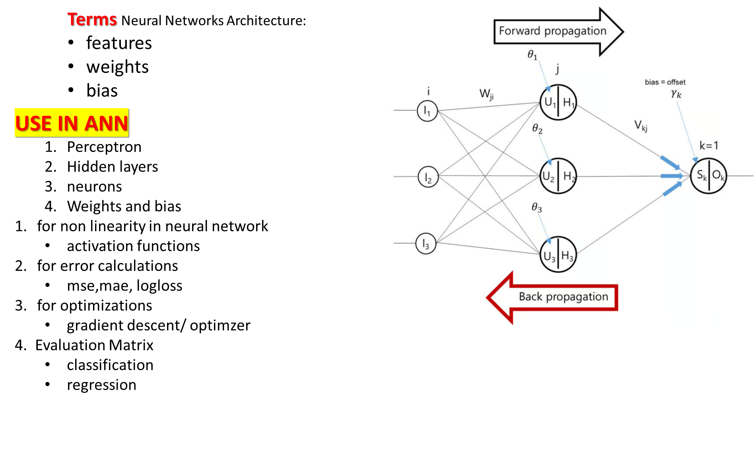

3. Loss Functions
Purpose: Measure how far predictions are from actual values.
Mean Squared Error (MSE):
MSE=1n∑i=1n(yi−y^i)2MSE = \frac{1}{n} \sum_{i=1}^n (y_i - \hat{y}_i)^2
Used in regression.
Cross-Entropy Loss:
CE=−∑i=1nyilog⁡(y^i)CE = -\sum_{i=1}^n y_i \log(\hat{y}_i)
Used in classification.

4. Backpropagation & Gradient Descent
Backpropagation:
- Calculates gradients (errors) layer by layer, updating weights to reduce loss.
Gradient Descent:
- Optimization method to find the lowest loss by adjusting weights.
Algorithm:
- Compute forward pass.
- Calculate loss.
- Compute gradients using chain rule.
- Update weights:
w=w−η⋅∂L∂ww = w - \eta \cdot \frac{\partial L}{\partial w}
where η\eta = learning rate.

Practical Example Dataset (50 datapoints)
Feature1 | Feature2 | Class
0.5 | 1.2 | 0
1.1 | 0.9 | 1
... | ... | ...

Business Scenario
Company: PayPal
Use Case: Fraud detection using ANN to classify transactions as fraud or safe.

Practice Session
- What is the role of weights?
- Implement forward propagation in NumPy.
- Compare MSE and Cross-Entropy.
- Why do we need bias?
- Explain gradient descent in one sentence.

Case Study
Company: Tesla
Use Case: ANN for self-driving perception module to detect pedestrians.

Assignments
- Implement ANN from scratch in NumPy for binary classification.

Quiz
- What is Softmax used for?
- Which loss function for regression?
- Formula for forward propagation?

Interview Questions
Theoretical:
- Difference between ANN and traditional ML.
- Why bias term is needed.
... (10 total)
Practical:
- Code forward propagation.
- Implement MSE loss.
... (10 total)

Streamlit Interface Example
I’ll create a small PyTorch ANN for binary classification with two buttons:
- Train Model
- Predict with Sample Data
With live accuracy updates.

Do you want me to now create the Streamlit + PyTorch full working code for this ANN lesson so learners can train & predict live?
It will also visualize training loss in real time.

